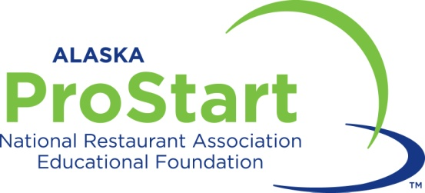

2018 Alaska ProStart Invitational Competition Registration Packet

All teams must be registered by Tuesday, December 19, 2017 by 5:00pm

Hannah Frost
ProStart Coordinator
Alaska CHARR Future Hospitality Leaders Program
1503 W. 31st Avenue Suite 202
Anchorage, Alaska 99501
(907) 274-8133 ext. 203
Fax (907) 274-8640
prostart@alaskacharr.com
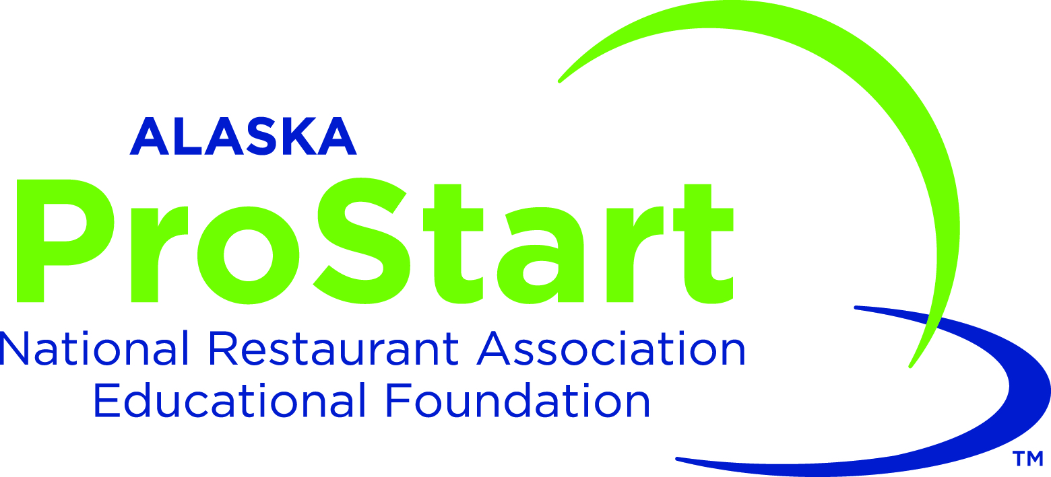
2018 Alaska ProStart Student Invitational
Intent to Participate

General Registration Information

1. School Name:

2. Teacher Full Name:

3. Teacher Phone/Cell:

4. Teacher D.O.B. ___/___/_____

5. Events in which we will compete:

A. _____ Management* (2-4 team members + 1 optional alternate per team)

B. _____ Culinary* (2-4 team members + 1 optional alternate per team)

6. We anticipate bringing _____ students, _____ teachers, _____ mentors total.

7. Any dietary restrictions or allergies?:

8. We are interested in a group rate at a hotel in Anchorage. ___ Yes ____ No

9. We anticipate needing ___________ hotel rooms.

10. Do you have students who are not competing but are interested in attending as a volunteer either on Friday or Saturday? (I will contact you separately about these students please do not include them in the registration packet.) ____ Yes _____No

*Team members competing in Management and/or Culinary events MUST be available to compete at the National ProStart Student Invitational in Providence, RI in late April 2018.
2018 Alaska ProStart Student Invitational
Intent to Participate

Team Information
Please fill this out for each team you are bringing. For example, if you are bringing one culinary and one management please fill out this form for each individual team. Another example: If you are bringing two culinary teams and two management teams, please fill out this form for each individual team.

Team names are optional and will be used to identify teams for schools that are bringing multiple teams.

- Team Name:
- Which Competition is this team competing in? (Circle one)
Management Culinary
- Student Names and grade:

Team Manager:

- Mentor Full Name*:
- Mentor’s Business or company:
- Mentor DOB*: ____/____/______
- Mentor email:
- Mentor cellphone:

*Alaska ProStart/Alaska CHARR will perform a background check on all teachers and mentors involved in the competition. This is to help ensure the safety of our students.

2018 Alaska ProStart Student Invitational
Intent to Participate

- Thank you message: you may provide a 100 word ‘thank you’ message that will accompany your team information in the competition program. Past messages have included thanks to mentors, team sponsors, educators, etc. You can attach your thank you in a separate document as well.

10. Please send a HIGH RESOLUTION PHOTO of this team in competition dress for use in the 2018 AK PSI Program to prostart@alaskacharr.com. Photos from an iPhone or comparable smartphone will work. If you are bringing more than one team I will need to know which photo is for which team. Please indicate which photo is which either in the body of the email or by changing the name of the photo file. Please use the team name listed above.
2018 Alaska ProStart Student Invitational
Intent to Participate

Letter of Intent and Checklist
Please initial next to each line and sign at the bottom.

_____ I have filled out the general registration information on page two of this packet.

_____ I have filled out a team registration on pages three and four for each individual team that I am bringing.

_____ I have confirmed that the information about my mentor(s) is correct.

_____ I have sent a photo of my teams and identified which team is which either in the body of the email or by the file name.

____ I have had each student (and their parent or guardian) that is competing fill out a participant waiver and release (page 6) and a Standards of Behavior Form(Page 7). Students without a waiver will not be allowed to participate in the competition.
____ I have had each student (and their parent or guardian) fill out a photo release form (page 8 and 9). Students without a photo waiver will not be allowed to participate in the competition.
____ I have triple checked that my packet is complete and there is no missing information or pages.

YES! We will participate at the Alaska ProStart Student Invitational and agree to comply with the rules and standards of behavior as stated in the rules and other information provided by Alaska ProStart for this event. I understand that Alaska ProStart/Alaska CHARR will complete a background on all teachers and mentors involved with the competition.

This Letter of Intent is due on December 19, 2017.

Teacher Signature Date

2018 Alaska ProStart Student Invitational
Participant Waiver and Release
Due December 19th, 2017

I (we) understand that I (we) hold Alaska CHARR Future Hospitality Leaders Program, Inc./Alaska ProStart and any affiliated entity, including Alaska Cabaret, Hotel, Restaurant, & Retailers Association, their officers, agents and employees harmless from any and all liability or claims, which may arise out of or in connection with my child's participation in the Alaska ProStart Student Invitational and related and surrounding activities, including but not limited to mandatory or optional events or tours ( collectively “the event”). I (we) fully understand that participants are to abide by all rules and regulations governing conduct during the trip. Any violation of these rules and regulations may result in that individual being sent home at the expense of his/her own and/or parent/guardian.

Misconduct, which includes, but is not limited, to alcohol or drug use (including cigarettes), at “the event”, during competition or in activities or locations related to or surrounding “the event”, may disqualify a participant or the participant's team from awards or further participation. Should any misconduct come to Alaska ProStart’s attention, the matter will be investigated, as Alaska ProStart deems appropriate. Any decision and sanction as to appropriate action due to misconduct is at the sole discretion of Alaska ProStart, and is final. By entering into the contest, the student and the team accept this requirement as well as all other conditions of the program.

I (we) hereby consent that Alaska CHARR Educational Fund, Inc./Alaska ProStart, its representatives, successors or assigns, shall have the right to publish or use any photographs, movie films, video tapes, digital images and/or sound recordings, submitted text or any part thereof, they have taken or made of me (student) on this date or in which I (student) may have been included, for publicity, advertising, Internet usage or any other lawful purpose in conjunction with my (student) own or a fictitious name or image, or in reproductions thereof in color. I (we) hereby waive all claims for any compensation for use or for damages. I (we) hereby waive any right that I (we) may have to inspect and/or approve the finished product or the use to which it may be applied. I (we) hereby warrant that I (we) have every right to contract in my (student) own name in the above regard. I (we) state further that I (we) have read the above authorization and release, prior to its execution, and that I (we) am fully familiar with the contents thereof. This form must be completed and signed before students are eligible to participate in the Alaska ProStart Student Invitational. I (we) have read, understand and agree to comply with the information in this document.

Name of Student (print):______________________________________________________________________
High School Name:___________________________________________________________________________

Student Email (optional):__________________________________@__________________________________

Parent/Guardian Name (print):___________________________________Telephone: ( ) -

Emergency Contact:_____________________________________________Telephone: ( ) -

Student Signature:________________________________________________________Date: ___/___/______

Parent/Guardian Signature:_______________________________________________Date: ___/___/______
Completed, signed Participant Waivers must be collected by educators and emailed or faxed to Hannah Frost at (907)274-8640

2018 Alaska ProStart Student Invitational
Standards of Behavior
Due December 19th, 2017

Alaska ProStart, the Alaska CHARR Education Fund, and Alaska CHARR aim to promote high standards of sportsmanlike and ethical behavior in and around the Alaska ProStart Invitational competition. Citizenship, Integrity, and Fairness is expected of all participants, mentors, judges, and employees of Alaska CHARR and the Alaska CHARR Education Fund (collectively “employees”). The following Standards of Behavior will be followed:

- The National ProStart Invitational Rules will be followed by all involved in the competition, unless otherwise stated in materials provided by Alaska ProStart. Know and understand these rules prior to attending competition.

- Poor sportsmanship, unethical behavior, bullying, and violence in any form will not be tolerated.

- The use or possession of alcoholic beverages is prohibited.

- The use or possession of illicit drugs is prohibited.

- No firearm or weapon is to be present on any person while on campus.

- Students will be accompanied by a parent/guardian, educator, mentor or approved supervisory entity.

- Students, teachers, and mentors will abide by their respective school district code of conduct or policy.

- Students, teachers, mentors, and employees will conduct themselves in a courteous, respectful manner and exercise self-control. Refrain from the use of foul and/or abusive language at all times.

I understand that my participation in the Alaska ProStart Invitational is a privilege. I have read, understand and accept the Standards of Behavior stated above. I agree to abide by this policy while participating in the Alaska ProStart Invitational competition. Any violation of this policy may result in my disqualification from the competition and possible disciplinary actions as stated in my school district policies.

___________________________ ___________________________ ___________________
Signature of Student Printed Name Date

___________________________ ___________________________ ___________________
Signature of Parent/Guardian Printed Name Date
2018 Alaska ProStart Student Invitational
Standards of Behavior
Due December 19th, 2017

Dear Educators, Parents, and Students,
Alaska ProStart has been presented with an amazing opportunity to create a Facebook/YouTube video to showcase the amazing opportunities that our program and industry provide for students across the state of Alaska. As such, Alaska ProStart has started to work with a videographer and will be filming at competition for this project.
The nature of the Alaska ProStart Invitational means that we cannot guarantee that you or your student will not be in the video. The next page is a photo release form specifically for this project. If your student wishes to compete or volunteer at competition they will need to have a signed copy of this release form on file with Alaska ProStart and Don Chon Photography.
If you have any questions or concerns about this project, please do not hesitate to contact me at any time. I can be reached by phone during normal business hours at 907-274-8133 or you can email me at prostart@alaskacharr.com
Thank you for all that you do for our students!

Sincerely,
Hannah Frost
Prostart Coordinator
1503 W 31st Avenue STE 202, Anchorage, Alaska 99503
Ph: (907) 274-8133, Fax: (907) 274-8640
prostart@alaskacharr.com
ProStart is a registered trademark of the National Restaurant Association Educational Foundation

Photo/Video Release Form

I, _____________________________________________________________(please print), grant permission to Alaska ProStart & Don Chon Photography and its agents and employees the irrevocable and unrestricted right to reproduce the photographs and/or video images taken of me, or members of my family, for the purpose of publication, promotion, illustration, advertising, or trade, in any manner or in any medium. I hereby release Alaska ProStart & Don Chon Photography and its legal representatives for all claims and liability relating to said images or video. Furthermore, I grant permission to use my statements that were given during an interview or guest lecture, with or without my name, for the purpose of advertising and publicity without restriction. I waive my right to any compensation.
I acknowledge that I am:
[ ] over the age of 18 [ ] the legal guardian of the following
If legal guardian of model(s), please list name(s) here:
Name(s): ________________________________________________________________
Signature: _________________________________________Date: _________________
Address: ________________________________________________________________
________________________________________________________________________
________________________________________________________________________

Revised November 2017

2018 Alaska ProStart Invitational
Dish Order Form
Due by January 15th, 2018

Please indicate the size of the dish you will need for the competition by writing in the number of pieces you need in the left hand column. All dishes will be solid white unless otherwise stated. If your school fails to return the form, you will be supplied the following dishes: 2 10” square plates (for entrée), 4 8” square plates (for appetizer and dessert).

School Name/Team Name:__________________________________

Number Needed | Description | Photo
 | 8” Au Gratin  5” Inner Plate | 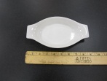
 | 12” Rectangular Plate  10” Inner Plate | 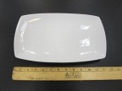
 | 11” Bowl  8” Inner Plate | 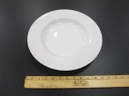
 | 8” Square Plate | 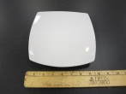
 | 4 ½” Large Ramekin | 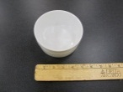
 | 10” Square Plate | 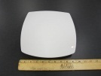
 | 7” Square Bowl  4” Inner Plate | 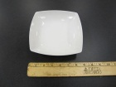
 | 9” Triangular Bowl  7” Inner Plate | 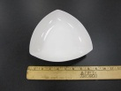
 | 6” Square Plate | 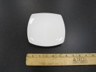
 | 5 ½” Triangular Bowl  2 ½” Inner Plate | 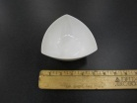
Coffee Cup
3” Opening, 2” Depth
Stemmed Water Glass
2 ¾” Opening, 4” Depth
Please fax this completed form to Hannah Frost at 907-274-8640 or by email to prostart@alaskacharr.com

